Nama : Erlangga Rizal Mahendra

NIM : 2440101704

Mo_9

1. Create a store procedure with named ‘sp1’ to display CustomerId, CustomerName, CustomerGender, and CustomerAddress for every Customer with Id based on user’s input.

(**create procedure**)

USE OOVEO_Salon

CREATE PROCEDURE [sp1] @id CHAR(5)

AS

BEGIN

SELECT CustomerId,

CustomerName,

CustomerGender,

CustomerAddress

FROM

MsCustomer

WHERE

CustomerId = @id

END;

EXEC sp1 'CU001';

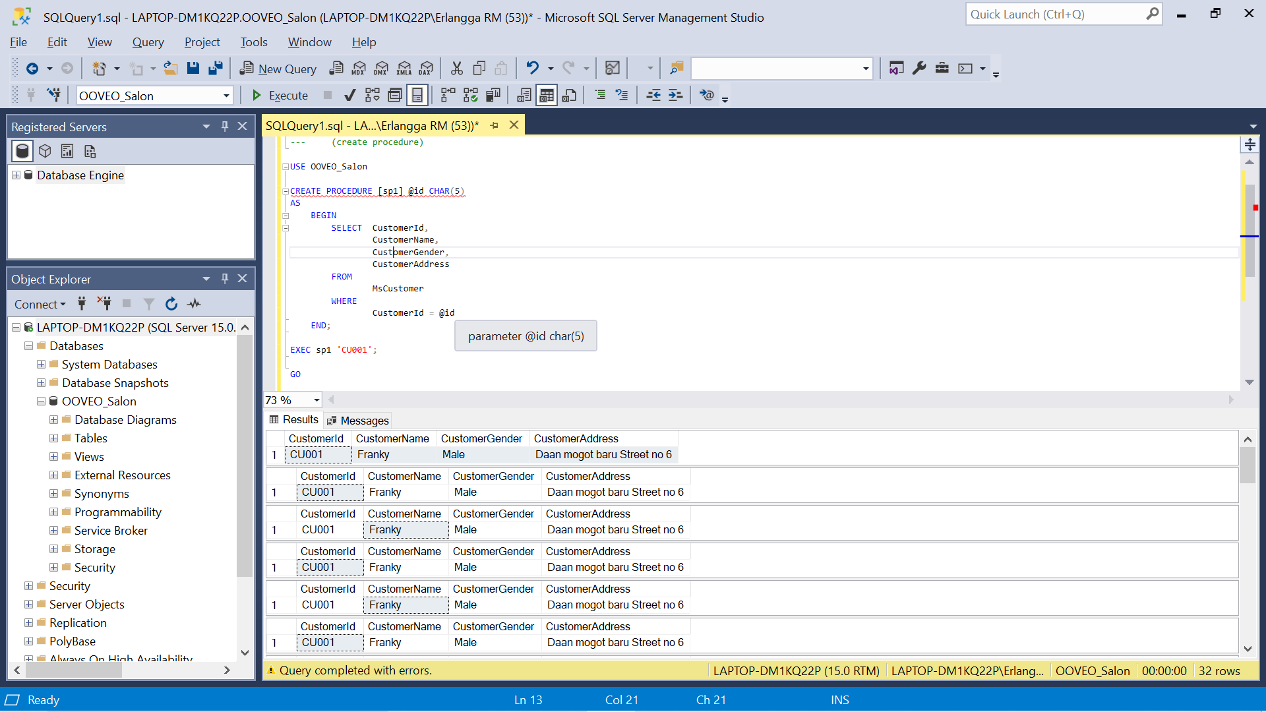GO

1. Create a store procedure with named ‘sp2’ that receives CustomerName as input from user with the following specification:

* If the length of CustomerName is odd then procedure will give output ‘**Character Length of Mentor Name is an Odd Number’**.
* If the length of CustomerName is even then procedure will display CustomerId, CustomerName, CustomerGender, TransactionId, and TransactionDate for every transaction with customer whose name contains the name that was inputted by user.

(**create procedure**, **len**, **like**)

USE OOVEO_Salon

CREATE PROCEDURE [sp2] @name VARCHAR(50)

AS

BEGIN

IF LEN(@name) % 2 = 1

BEGIN

PRINT 'Character Length of Mentor Name is an Odd Number'

END

ELSE

BEGIN

SELECT

MsCustomer.CustomerId,

MsCustomer.CustomerName,

MsCustomer.CustomerGender,

HeaderSalonServices.TransactionId,

HeaderSalonServices.TransactionDate

FROM

MsCustomer

INNER JOIN

HeaderSalonServices ON HeaderSalonServices.CustomerId = MsCustomer.CustomerId

WHERE

MsCustomer.CustomerName LIKE '%' + @name + '%'

END

END;

EXEC sp2 'Elysia Chen';

EXEC sp2 'Fran';

GO

EXEC sp2 ‘Elysia Chen’

EXEC sp2 ‘Fran’

3. Create a store procedure named ‘sp3’ to update StaffId, StaffName, StaffGender, and StaffPhone on **MsStaff** table based on StaffId, StaffName, StaffGender, and StaffPhone that was inputted by user. Then display the updated data if the StaffId exists in **MsStaff** table. Otherwise show message ‘**Staff does not exists**’.

(**create procedure**, **update**, **exists**)

USE OOVEO_Salon

CREATE PROCEDURE [sp3] @id CHAR(5), @name VARCHAR(50), @gender VARCHAR(10), @phone VARCHAR(13)

AS

BEGIN

IF EXISTS(

SELECT StaffId

FROM MsStaff

WHERE StaffId = @id

AND StaffName = @name

AND StaffGender = @gender

AND StaffPhone = @phone

)

BEGIN

-- Update data

UPDATE MsStaff

SET StaffId = @id,

StaffName = @name,

StaffGender = @gender,

StaffPhone = @phone

WHERE StaffId = @id

-- Check if data is updated

SELECT *

FROM MsStaff

WHERE StaffId = @id

END

ELSE

BEGIN

-- Data not exists

PRINT 'Staff does not exists'

END

-- Check all data

SELECT *

FROM MsStaff

END;

EXEC sp3 'SF005', 'Ryan Nixon', 'M', '08567756123'

EXEC sp3 'SF008', 'Ryan Nixon', 'M', '08567756123'

GO

drop procedure sp3

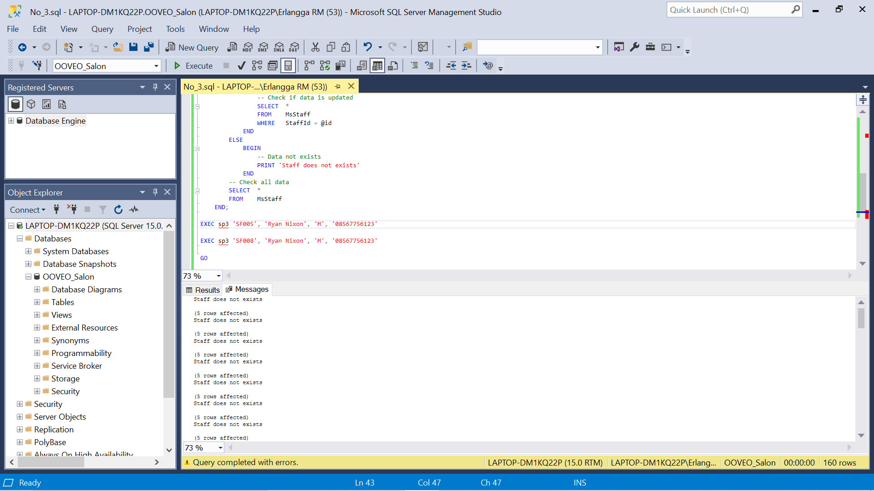

4. Create trigger named ‘trig1’ for **MsCustomer** table to validate if there are any data which had been updated, it will display before and after updated data on **MsCustomer** table.

(**create trigger**, **union**)

USE OOVEO_Salon

CREATE TRIGGER [trig1] ON MsCustomer

FOR UPDATE

AS

BEGIN

SELECT * FROM INSERTED

UNION

SELECT * FROM DELETED

END

SELECT * FROM MsCustomer

BEGIN TRANSACTION

UPDATE MsCustomer

SET CustomerName = 'Franky Quo'

WHERE CustomerId = 'CU001'

SELECT * FROM MsCustomer

ROLLBACK

GO

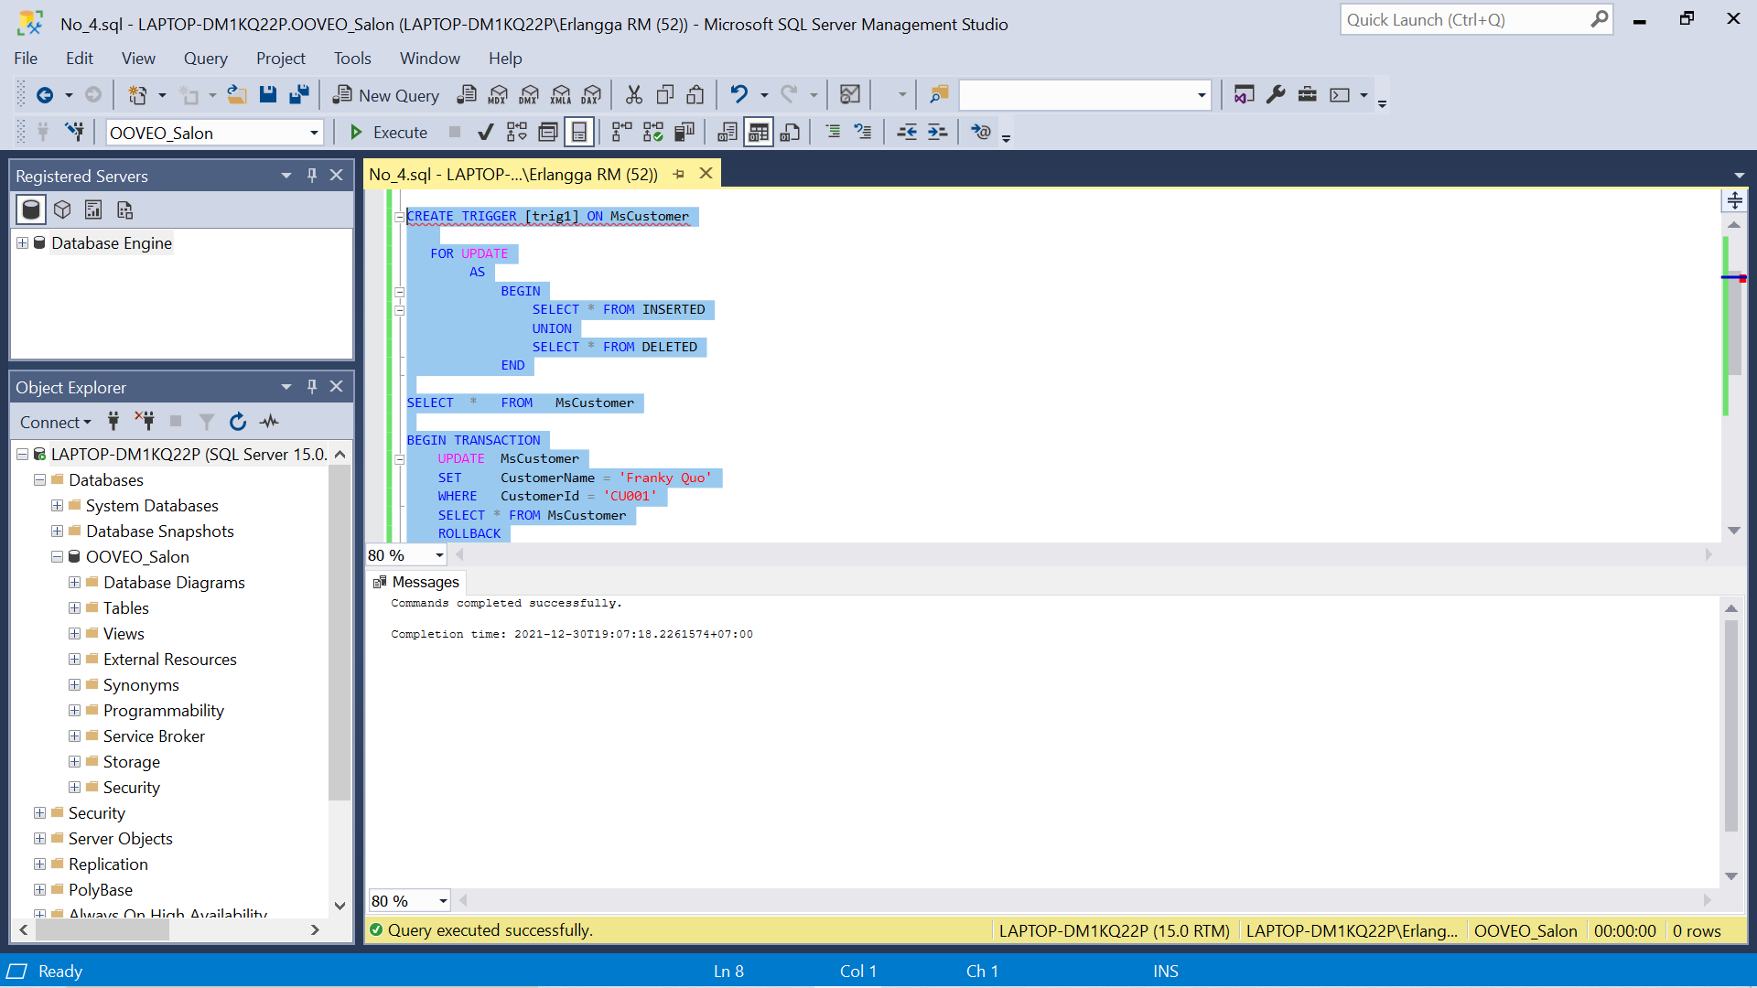

5. Create trigger with name ‘trig2’ for **MsCustomer** table to validate if there are any new inserted data, then the first data on **MsCustomer** will be deleted.

(**create trigger**, **top**, **delete**)

USE OOVEO_Salon

CREATE TRIGGER [trig2] ON MsCustomer

AFTER UPDATE

AS

BEGIN

DELETE TOP(1)

FROM MsCustomer

END

BEGIN TRANSACTION

INSERT INTO MsCustomer

(

CustomerId,

CustomerName,

CustomerGender,

CustomerPhone,

CustomerAddress

)

VALUES (

'CU006',

'Yogie Soesanto',

'Male',

'085562133000',

'Pelsakih Street no 52'

)

SELECT *

FROM MsCustomer

ROLLBACK

SELECT *

FROM MsCustomer

GO

6. Create trigger with name ‘trig3’ on **MsCustomer** table to validate if the data on **MsCustomer** table is deleted, then the deleted data will be insert into **Removed** table. If **Removed** table hasn’t been created, then create the **Removed** table and insert the deleted data to **Removed** table.

(**create trigger**, **object_id**, **is not null**, **insert**, **select into**)

USE OOVEO_Salon

CREATE TRIGGER [trig3]

ON MsCustomer

FOR DELETE

AS

BEGIN

IF OBJECT_ID('REMOVED') IS NOT NULL

BEGIN

INSERT INTO [REMOVED]

SELECT *

FROM MsCustomer

END

ELSE

BEGIN

SELECT *

INTO [REMOVED]

FROM MsCustomer

END

END

BEGIN TRANSACTION

DELETE FROM MsCustomer

WHERE CustomerId = 'CU002'

SELECT * FROM MsCustomer

SELECT * FROM [REMOVED]

ROLLBACK

DROP TRIGGER [trig3]

GO

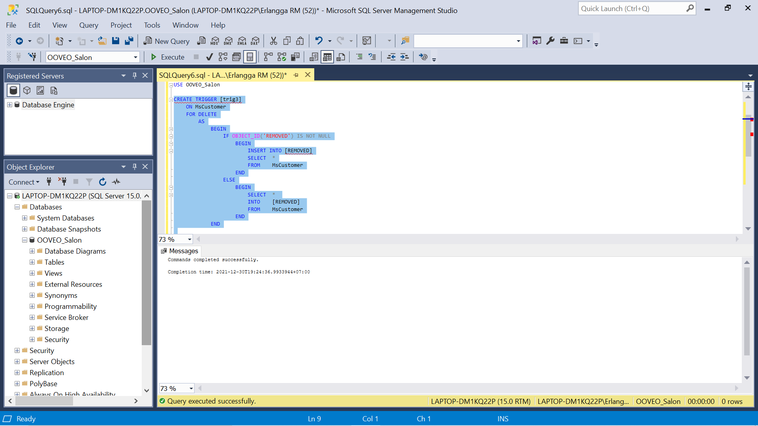

7. Create cursor with name ‘cur1’ to validate whether the length of StaffName is odd or even then show the message about result.

(**declare cursor**, **len**)

USE OOVEO_Salon

DECLARE @name VARCHAR(50)

DECLARE [cur1] CURSOR

FOR

SELECT StaffName

FROM MsStaff

OPEN [cur1]

FETCH NEXT FROM [cur1] INTO @name

IF @@FETCH_STATUS <> 0

PRINT 'Cursor Fetch Failed!'

WHILE @@FETCH_STATUS = 0

BEGIN

IF LEN(@name) % 2 = 0

BEGIN

PRINT 'The length from StaffName ' + @name + ' is an odd number'

END

ELSE

BEGIN

PRINT 'The length from StaffName ' + @name + ' is an even number'

END

FETCH NEXT FROM [cur1] INTO @name

END

CLOSE [cur1]

DEALLOCATE [cur1]

GO

8. Create procedure named ‘sp4’ that receive StaffName from user’s input to display StaffName and StaffPosition for every staff which name contains the word that has been inputted by user.

(**create procedure**, **declare cursor**, **like**)

USE OOVEO_Salon

CREATE PROCEDURE [sp4] @search VARCHAR(50)

AS

BEGIN

DECLARE [cur2] CURSOR

FOR

SELECT StaffName,

StaffPosition

FROM MsStaff

WHERE StaffName LIKE '%' + @search + '%'

DECLARE

@name VARCHAR(50),

@position VARCHAR(20)

OPEN [cur2]

FETCH NEXT FROM [cur2] INTO @name, @position

IF @@FETCH_STATUS <> 0

PRINT 'Cursor Fetch Failed!'

WHILE @@FETCH_STATUS = 0

BEGIN

PRINT 'StaffName : ' + @name + ' : ' + @position

FETCH NEXT FROM [cur2] INTO @name, @position

END

CLOSE [cur2]

DEALLOCATE [cur2]

END

EXEC [sp4] 'a'

DROP PROCEDURE sp4

GO

9. Create procedure with name ‘sp5’ that receive CustomerId from user’s input to display CustomerName, and TransactionDate for every customer which Id has been inputted by user and did treatment which ID is an even number.

(**create procedure**, **declare cursor**, **in**, **right**)

USE OOVEO_Salon

CREATE PROCEDURE [sp5] @id CHAR(5)

AS

BEGIN

DECLARE [cur3] CURSOR

FOR

SELECT MsCustomer.CustomerName,

HeaderSalonServices.TransactionDate

FROM MsCustomer

JOIN HeaderSalonServices

ON MsCustomer.CustomerId = HeaderSalonServices.CustomerId

WHERE MsCustomer.CustomerId IN (@id)

DECLARE

@nama VARCHAR(50),

@date DATE

OPEN [cur3]

FETCH NEXT FROM [cur3] INTO @nama, @date

IF @@FETCH_STATUS <> 0

PRINT 'Cursor Fetch Failed!'

WHILE @@FETCH_STATUS = 0

BEGIN

PRINT 'Customer Name : ' + @nama + ' Transaction Date is ' + CAST(@date AS VARCHAR)

FETCH NEXT FROM [cur3] INTO @nama, @date

END

CLOSE [cur3]

DEALLOCATE [cur3]

END

EXEC [sp5] 'CU001'

GO

10. Delete all procedure and trigger that has been made.

(**drop proc**, **drop trigger**)

USE OOVEO_Salon

DROP PROCEDURE

[sp1], [sp2], [sp3], [sp4], [sp5]

DROP TRIGGER

[trig1], [trig2], [trig3]

